**NatureServe Rapid Analysis of Rarity and Endangerment Conservation Assessment Tool (RARECAT) Documentation**

*Version*: 1.1.1 (released Mar 31, 2025)

*Documentation Last Updated*: Mar 31, 2025

*Contact*: [Amanda_Eberly@natureserve.org](mailto:Amanda_Eberly@natureserve.org)

1. Background 2

2. How-to Guide 2

2.1. Application 2

2.2. Interface 3

2.2.1. Single Species 3

2.2.1.1. Search Bar 3

2.2.1.2. Map 4

2.2.1.3. Data and Analysis Panel 5

2.2.1.4. Filters Panel 7

2.2.1.5. Occurrences Table 7

2.2.1.6. Temporal Trends Panel 8

2.3. Workflow 9

2.3.1. Step 1. Select taxon or move forward with “New taxon” 9

2.3.2. Step 2. Load data 9

2.3.3. Step 3. Explore and vet records 9

2.3.4. Step 4. Quantify rarity metrics 10

2.3.5. Step 5. Update records included and rarity metrics 10

2.3.6. Step 6. Download outputs 10

2.3.7. Step 7. Clear map and start fresh 10

3. Methodology 10

3.1. Taxonomy 10

3.2. Importing Data 11

3.3. Mapping 11

3.4. Filters 11

3.4.1. GBIF Filter 11

3.4.2. Centroids Filter 12

3.4.3. Time Frame Filter 12

3.4.4. No Year Filter 12

3.4.5. Spatial Uncertainty Filter 13

3.4.6. Nation and Subnation Filters 13

3.4.7. Taxon Filter 13

3.4.8. Data Source Filter 13

3.5. Rarity Metrics 13

3.5.1. Range Extent 13

3.5.2. Area of Occupancy 14

3.5.3. Number of Occurrences 15

4. Outputs 15

4.1. Analysis Records 16

4.2. Rank Calculator 16

# Background

NatureServe Conservation Status Assessments quantify Rarity, Threat, and Trend Factors for target taxa to produce Conservation Assessment Status Ranks at global (G Rank), national (N Rank), or subnational scales (S Rank). NatureServe’s RARECAT (Rapid Analysis of Rarity and Endangerment Conservation Assessment Tool) facilitates extraction, vetting, and filtering of distribution data, visualization of data quality and quantity over space and time, and calculation of the three fundamental factors of Rarity – Range Extent (also known as Extent of Occurrence/EOO), Area of Occupancy (AOO), and Number of Occurrences. Doing so, RARECAT supports higher quality, efficiency, and standardization in Conservation Assessment Status ranking practice for both common and rare taxa. RARECAT can be accessed at [**https://natureserve.shinyapps.io/RARECAT**](https://natureserve.shinyapps.io/RARECAT).

To cite RARECAT, we suggest the following citation template:

NatureServe (2025). RARECAT version 2.1.1. Available from https://natureserve.shinyapps.io/RARECAT. Accessed [Date].

# How-to Guide

## Application

RARECAT is an R Shiny application hosted on NatureServe’s shinyapps.io account (natureserve.shinyapps.io). Use your browser to navigate to the stable up-to-date version of RARECAT at the following URL: [**https://natureserve.shinyapps.io/RARECAT**](https://natureserve.shinyapps.io/RARECAT).

## Interface

### Single Species

RARECAT “Single Species” mode follows a relatively simple user interface with a single page including 6 components (Figure 1): 1) the Search bar, 2) the Map, 3) the Data and Analysis panel, 4) the Filters panel, 5) the Records Table, and 6) the Temporal Change panel.

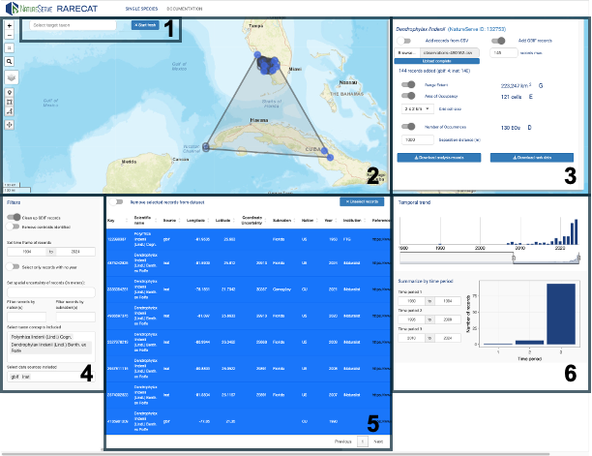

**Figure 1**: The RARECAT Single Species user interface comprises 6 components: 1) the Search bar, 2) the Map, 3) the Data and Analysis panel, 4) the Filters panel, 5) the Records Table, and 6) the Temporal Trends panel.

#### Search Bar

The Search Bar appears on the top left of the page and prompts the user to “Select a target taxon”. Selection of a target taxon represents a frequent though not necessary first step to ranking assessments. Currently, the Search Bar enables searching through taxa included within the NatureServe Taxonomy Backbone served via the NatureServe Explorer API and the GBIF Taxonomic Backbone served via the GBIF API (Figure 2A). Once a taxon is selected from the Search bar, the selection will represent the umbrella taxonomic concept under assessment and its name will appear on the top of the Data and Analysis Panel (Figure 5).

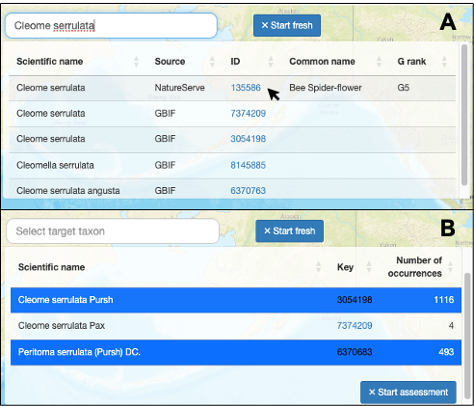

**Figure 2**: The Search Bar enables the user to select a target taxon for the ranking assessment. Clicking on the taxon’s “EGT ID” will navigate to the NatureServe Explorer page for the corresponding NatureServe Element.

Because the taxon concept selected may have several relevant synonyms or infra-species, and to ensure that records from all relevant taxa are included in the assessment, the Search Bar presents the user with a second table displaying all GBIF scientific names linked to the target taxon selected with at least 1 record on GBIF (Figure 2B). The user is able to select one or more of the relevant scientific names and click “Start assessment” to begin the assessment using all taxon concepts selected.

#### Map

The interactive map enables the user to explore, select, and filter records that have been added to the ranking assessment for the target taxon. Once added, records are displayed on the map as gray circle markers that scale with the map’s zoom level. Current map functionality includes: zooming in/out buttons, restoring map to full extent (i.e. North America), changing basemap (toggle between ESRI World Street Map, ESRI World Terrain, ESRI World Imagery, and OpenStreetMap), drawing point record, drawing selection box, drawing selection polygon, and dragging drawn shapes. The buttons available to support map functionality are described in Figure 2.

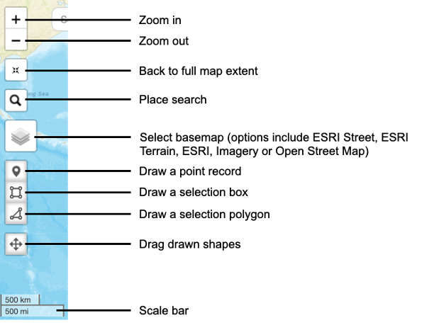

**Figure 3**: Functionality available within the interactive mapping interface.

Of particular note, the “Draw a point record” button enables users to create data or add to uploaded data by selecting particular locations on the map, while the “Draw a selection box” and “Draw a selection polygon” buttons enable users to select subsets of records to be examined more closely and/or removed (Figure 3).

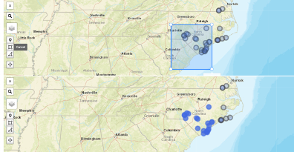

**Figure 4**: The “Draw a selection box” and “Draw a selection polygon” buttons enable the user to select a subset of mapped records to be sent to the interactive Records Table.

#### Data and Analysis Panel

The Data and Analysis panel summarizes the main inputs into and outputs from the ranking assessment. Input records for the target taxon under assessment can be imported from one or more of three sources: 1) open online data repositories including the Global Biodiversity Information Facility and associated sources queried via respective Application Programming Interfaces, 2) comma-delimited file(s) added by the user, and 3) direct additions to the map using the “Draw a point record” tool.

Once records are added, the “Data and Analysis” Panel will display the number and source of records added to the analysis and enable the user to turn on the calculation for one or more of the three metrics of Rarity: Range Extent, Area of Occupancy, and Number of Occurrences (Figure 6). When turned on, each metric value will appear in the Data and Analysis Panel to the right of the metric’s toggle and the metric’s spatial representation will be displayed on the map. Symbology for the three Rarity metric spatial layers is as follows: Range Extent is displayed as a large gray polygon surrounding all mapped point records; Area of Occupancy is displayed as sets of blue square/rectangular grid cells of the chosen grid cell size; and the Number of Occurrences is displayed as red circular buffers around each point records, intersecting red circular buffers are considered part of the same “Occurrence”. See Methodology section to learn more about how the three metrics of Rarity are quantified.

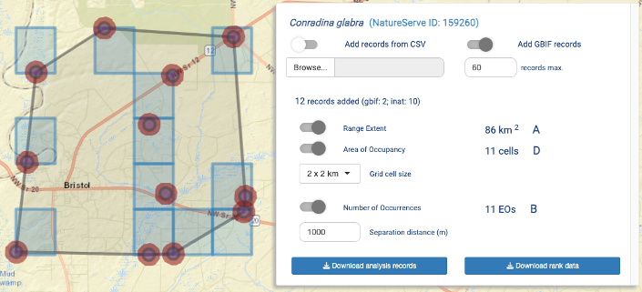

**Figure 5**: Distribution records for the target taxon can be added to an assessment using the Data and Analysis Panel via two main ways: by turning on the “Add GBIF records” toggle to import records from GBIF and associated online data sources, and/or by turning on the “Add records from CSV” and browsing to a local folder on the user’s machine. Once records are added to the map, the three metrics of Rarity – Range Extent, Area of Occupancy, and Number of Occurrences – can each be calculated and mapped by turning on the respective toggle in the Data and Analysis Panel. Range Extent is displayed as a large gray polygon surrounding all mapped point records; Area of Occupancy is displayed as sets of blue square/rectangular grid cells of the chosen grid cell size; and the Number of Occurrences is displayed as red circular buffers around each point records, intersecting red circular buffers are considered part of the same “Occurrence”.

The imported, selected, and filtered records can be exported from RARECAT using the “Download analysis records” button; the Rarity metric values calculated, as well as additional information about the target taxon (derived from the NatureServe Explorer API), can be downloaded as a comma-delimited values (CSV) file formatted as a NatureServe Rank Calculator (see Outputs section).

#### Filters Panel

The Filters Panel in the bottom left of the Single Species page enables selecting filters that are applied wholesale to the Rank Assessment dataset, thus providing users with greater flexibility and efficiency in narrowing down the most desirable dataset to quantify Rarity metrics. Available filters are described in Figure 6. Find additional details in the Filters subsection of the Methodology section.

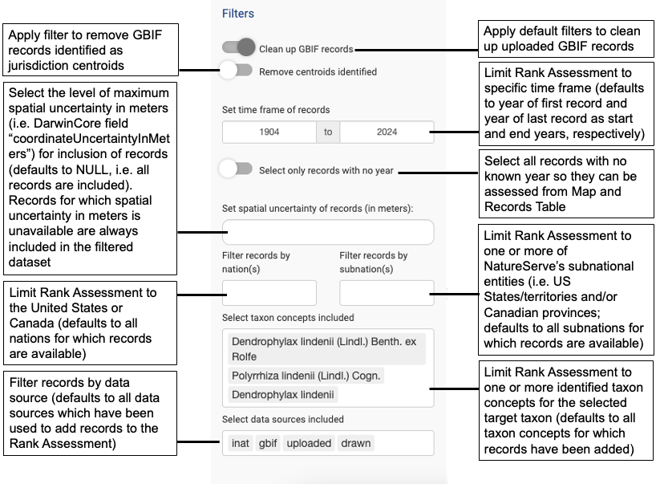**Figure 6**: Description of filters available from the Filters panel.

#### Occurrences Table

The interactive Occurrences Table enables the user to examine basic metadata on the subset of point records selected from the map using the The “Draw a selection box” and “Draw a selection polygon” buttons (see Figure 4). The basic metadata reported for each record are: 1) the unique ID or Key (which hyperlinks to the available online page for the record, if recognized); 2) the Scientific Name associated with the record; 3) the source of the record in RARECAT (one of gbif, uploaded, or drawn); 4) the longitude and latitude of the record as unprojected coordinates; 5) the spatial uncertainty of longitude/latitude coordinates, if available (DarwinCore field coordinateUncertaintyInMeters); 6) the NatureServe Subnation (i.e. the US State/territory or Canadian province) the record overlaps; 7) the NatureServe Nation the record overlaps (US or Canada); 8) the year the record was made/collected; 9) the Institution or Organization which owns or provides the record. The interactive Occurrences Table enables removing single records at a time (by clicking on the corresponding row) or all records by turning on the “Remove selected records from dataset” toggle. Selected records can be unselected by clicking the “Unselect records” button.

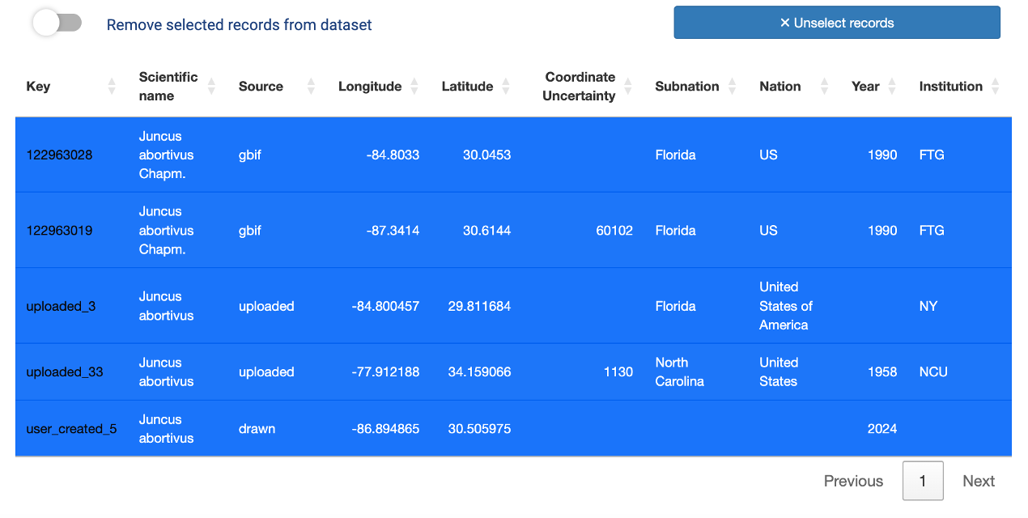

**Figure 8:** The interactive Occurrences Table reports basic metadata for the records selected from the map and enables removing single records at a time (by clicking on the corresponding row) or all records by turning on the “Remove selected records from dataset” toggle. Selected records can be unselected by clicking the “Unselect records” button.

#### Temporal Trends Panel

The temporal trends panel provides a temporal breakdown of the records included in the Rank Assessment. The dataset underlying the graphs in the Temporal Trends Panel corresponds to the entire set of records being included on the Map. The Temporal Trends Panel includes two visualizations: 1) a barchart showing the number of records in each year included in the Rank Assessment time frame (as specified in the time frame filter of the Filters Panel, see Figure 7); and 2) a barchart summarizing the number of records among up to 3 multi-year time periods (Figure 9). The Temporal Trends Panel allows interactivity by enabling the user to update the time frame of the top barchart using the date range slider below the barchart, as well as updating the years shown in the year range text boxes for Time periods 1-3 in the bottom barchart.

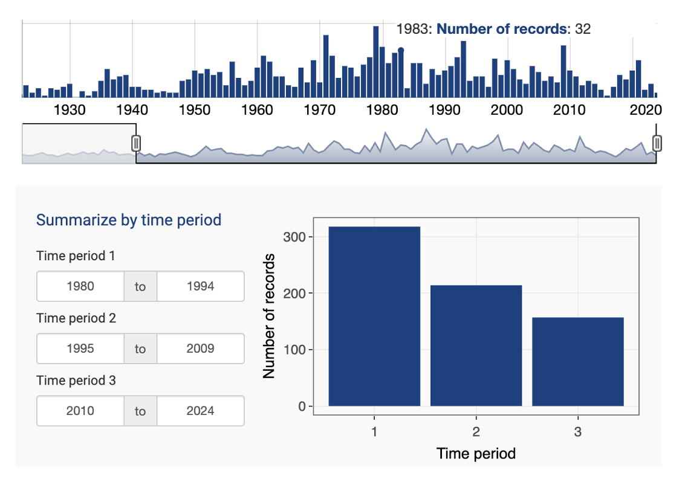

**Figure 9:** The Temporal Trends Panel provides a temporal breakdown of the records included in the Rank Assessment.

## Workflow

### Step 1. Select taxon or move forward with “New taxon”

A new ranking assessment can begin in one of two ways: if the taxon being ranked has an existing recognized NatureServe Global Element ID (i.e. EGT ID) available on NatureServe Explorer or a recognized GBIF taxon available from GBIF.org, the user should search for and select it using the “Search Bar”; else, the assessment can move forward without the selection of an existing NatureServe Element and the taxon being ranked will simply be “New taxon”.

### Step 2. Load data

Following the existing or new taxon selection, the user should move forward by loading species point records in one or more of the following ways: from GBIF (and associated online data sources) using the “Add GBIF records” toggle; from a local comma-delimited values (CSV) file using the “Add records from CSV” toggle; or by drawing records directly on the map using the Map’s “Draw point records” tool.

### Step 3. Explore and vet records

After having added data to the map, the user should proceed to verify that the data loaded represent the target taxon’s distribution and range. Unreliable or erroneous records should be removed from the assessment. Removal of records can be done using the following functionality: by navigating to and/or selecting single or multiple records through the Map interface or, by applying filters to the whole dataset using the “Filters” panel. In addition, the “Temporal Trends” panel can also be used to verify the breakdown of records over years to further inform filtering over time.

### Step 4. Quantify rarity metrics

Once a suitable species point record dataset has been identified, the user can now proceed to calculate one or more of the rarity metrics by turning on or off the corresponding toggle from the “Data and Analysis” panel, and choosing the desirable parameters for each (e.g. grid cell size for “Area of Occupancy” or separation distance for “Number of occurrences”).

### Step 5. Update records included and rarity metrics

Further updates to the underlying set of species point records will lead to updates in the value of each rarity metric included in the assessment.

### Step 6. Download outputs

Once reached reliable values of each metric for the target taxon, the user can proceed to download 1) the filtered set of species point records and associated metadata, and 2) the formatted rank calculator Excel file including the values of the rarity metrics quantified, as well as additional information about the target taxon.

### Step 7. Clear map and start fresh

Once the outputs downloaded for the current target taxon, a new assessment should be started by clicking the “Start fresh” button to the right of the “Search bar”.

# Methodology

## Taxonomy

The “Search Bar” enables looking up taxon concepts based on two sources: NatureServe Taxonomic Backbone (accessed via the NatureServe Explorer API) and GBIF Taxonomic Backbone (accessed via the GBIF API). The user can choose the target taxon for a new rank assessment based on the taxon concept and ID listed by either one of these taxonomic sources. Alternatively, the user may move forward without selecting a taxon altogether and ranking a “New taxon”. After some text is entered in the Search Bar, taxon suggestions from both NatureServe and GBIF appear in a table below. More information on each taxon concept displayed can be accessed by clicking on the corresponding taxon ID (which provides a link to the relevant taxon page on NatureServe Explorer or gbif.org). The user is prompted to select a target taxon for the assessment by clicking on the relevant table row, which will become highlighted in blue.

Once a target taxon is selected for assessment, its name and ID will appear on the top of the Data and Analysis panel: this will be the umbrella target taxon for the current rank assessment. However, since a given taxon concept may have several synonyms or related infra-species, RARECAT provides an explicit breakdown of all records available from GBIF across all scientific names connected with the target taxon selected. This information is provided in a second table below the Search Bar. The options presented on this table correspond to all scientific names provided by the GBIF API as synonyms or infra-species of either 1) the GBIF taxon concept selected as target taxon, 2) the NatureServe element selected as target taxon, as well as all of the synonyms provided for it by the NatureServe Explorer API. The user is prompted to select all relevant scientific names related to the target taxon for which records ought to be included in the assessment.

## Importing Data

Data can be imported into RARECAT from one or both of the following sources: 1) from GBIF using the “Add GBIF records” toggle; 2) from a local comma-delimited values (CSV) file on the user’s machine, using the “Add records from CSV”.

GBIF records are imported into RARECAT using the GBIF API via the R package SPOCC (https://docs.ropensci.org/spocc/). By default, switching on the “Add GBIF records” toggle on RARECAT will add all records available on GBIF across all scientific names selected from the Search Bar. However, the user is able to reduce the maximum number of records to be imported using the “max. Records” text box below the “Add GBIF records” toggle; this may lead to a situation where not all selected scientific names are added to the assessment. To ensure that all records associated with the user’s selected taxa are added to the assessment, the default maximum number of records should be kept as is.

## Mapping

Mapping in RARECAT is done using the [Leaflet package for R](https://cran.r-project.org/web/packages/leaflet/index.html) (Cheng et al. 2024). The Leaflet package expects all point data to be specified in latitude and longitude using WGS 84 (EPSG:4326). By default, when displaying this data, Leaflet projects everything to Web Mercator (also known as WGS 84/Pseudo-Mercator) projection (EPSG:3857). All records loaded directly from GBIF are always in WGS 84. Please note that RARECAT assumes that any longitude and latitude coordinate values uploaded by the user from a CSV file are in WGS 84. No spatial transformations are implemented in RARECAT prior to mapping records for exploration; errors are likely to emerge from the upload of records with longitude and latitude values not in WGS 84.

## Filters

### GBIF Filter

By default, the following filters are applied to GBIF records for the target taxon imported via the “Add GBIF records” toggle:

* Records have coordinates
* Records have some value at least for fields latitude, longitude, and basisOfRecord
* institutionCode does not equal “iNaturalist” (iNaturalist records are loaded independently from the iNaturalist API)
* latitude and longitude are both not 0
* basisOfRecord does not equal FOSSIL_SPECIMEN, LIVING_SPECIMEN, MATERIAL_SAMPLE
* occurrenceStatus equals PRESENT
* coordinateUncertaintyInMeters does not equal 999, or 9999
* samplingProtocol does not equal "from a cultivated plant of known (indirect) wild origin", or "grown"
* Only the first record is kept if there are duplicate records that have the exact same combination of latitude, longitude, speciesKey, and datasetKey

These default filters can be cleared by turning the “Clean up GBIF records” toggle off and reloading all GBIF records. When the “Clean up GBIF records” toggle is off, all available GBIF records are imported so long as they are have both latitude and longitude coordinates and both do not equal 0.

### Centroids Filter

Turning on the “Remove centroids identified” toggle will filter out all records identified as corresponding to jurisdiction centroids (e.g. city, county, state, or country centroids). Specifically, RARECAT does this by applying the following filters to GBIF records:

* Remove records that have georeferenceRemarks including the words “centroid”, “Centroid”, or “CENTROID”
* Removing records where uncertainty equals 301 or 3036, which are values known to be used to identify various kinds of jurisdiction centroids

### Time Frame Filter

A time frame filter can be applied to exclude records from the rank assessment. This can be done by entering the start and end years for the desired analysis time frame in the respective text boxes under the “Set time frame of records” section of the “Filters” panel. It is important to note that records which do not have a value available for year or date will remain included in the analysis regardless of the time frame specified.

### No Year Filter

All records with a missing value for Year can be selected at once by turning on the “Select only records with no year” toggle. This enables the user to further assess all records which do not have a year value, and could therefore be erroneous or misleading, by using the Map and the Records Table.

### Spatial Uncertainty Filter

Records can be excluded from the rank assessment based on a specified level of uncertainty in the precision of spatial coordinates. This can be done by entering the desired level of coordinate uncertainty in meters above which records should be excluded. It is important to note that records which do not have a value available for spatial uncertainty will remain included in the analysis regardless of the coordinate uncertainty level specified.

### Nation and Subnation Filters

Rank assessments can be limited to a given Nation (either the United States of America or Canada) or Subnation (US state/territory or Canadian province/territory; <https://www.natureserve.org/ns-network-directory>) by selecting the desired geographical unit using the “Filter records by nation(s)” and “Filter records by subnation(s)” dropdown menus in the “Filters” section. Note that only nations and subnations corresponding to records added to the map will be available for selection in the dropdown menus.

### Taxon Filter

Rank assessments can be limited to a subset of taxon concepts for the target taxon by selecting the desired taxon concepts to be included using from the “Select taxon concepts included” box.

### Data Source Filter

Given data sources can be included or excluded from the rank assessment using the

“Select data sources included” box. The data source categories that can be selected, provided at least one record has been imported from that data source, are: “gbif” to include/exclude all records loaded from the GBIF API, not including iNaturalist records; “inat” to include/exclude all records loaded from the GBIF API where the institutionCode DarwinCore field equals to “iNaturalist”; “uploaded” to include/exclude all records uploaded by the user; “drawn” to include/exclude all records drawn by the user directly on the Map.

## Rarity Metrics

### Range Extent

Range Extent is one of the spatial metrics used in NatureServe Rank Assessments to quantify the rarity and endangerment of the species assessed. NatureServe’s definition of this metric follows the IUCN Red List of Threatened Species definition for Extent Of Occurrence (EOO): the area within the shortest continuous line that can be drawn to include all known, inferred, or projected locations of a species, excluding vagrancy. In practice, Range Extent is therefore calculated by drawing a minimum convex polygon around a minimum of three point records.

RARECAT calculates and maps Range Extent using the following steps:

1. Unprojected longitude and latitude coordinates in WGS 84 are reprojected to a suitable area projection, that is either Cylindrical Equal-Area projection for latitudes below 70 degrees or Lambert Azimuthal Equal-Area projection for polar areas (latitudes above 70 degrees).
2. A minimum convex polygon is drawn around all point records included in the assessment (provided there are at least 3 point records; a value of NA will be returned otherwise).
3. The area of the minimum convex polygon is calculated and returned in square kilometers in the “Data and Analysis Panel” to the right of the “Range Extent” toggle.
4. A minimum convex polygon is also calculated from the unprojected longitude and latitude coordinates (in WGS 84) for the purpose of mapping and is added to the map as a grey polygon.

Please note that the mapped Range Extent polygon and the Range Extent polygon used to calculate the Range Extent value are not equivalent as they are calculated over unprojected and projected space, respectively. The Range Extent polygon that is mapped could potentially be distorted or fail to encapsulate all point records mapped, especially for very large-ranging and/or circumpolar taxa. Irrespective of potential web mapping issues, the returned value for Range Extent represents the best approximation of the area of the minimum convex polygon in an equal-area projection. Additionally, the spatial configuration of some point records datasets may lead to issues in the calculation of a minimum convex polygon and, therefore, a Range Extent value; this is particularly the case for taxa where few outliers are geographically distant from the majority of point records.

Assignment of scores for Range Extent

### Area of Occupancy

Area of Occupancy (AOO) is one of the spatial metrics used in NatureServe Rank Assessments to quantify the rarity and endangerment of the species assessed. NatureServe’s definition of this metric follows the IUCN Red List of Threatened Species definition: a statistic to represent the area of suitable habitat that a taxon occupies within its range extent. In practice, AOO is calculated by placing a grid over all selected taxon records within a user-defined area, with a default grid size of 2 km (alternatively, grid size can be set at 1km).

RARECAT calculates and maps Area of Occupancy using the following steps:

1. Unprojected longitude and latitude coordinates in WGS 84 are reprojected to Universal Transverse Mercator - a suitable area projection. Please note that all coordinates are reprojected to the UTM zone that corresponds to the minimum longitude value in the dataset.
2. The number of unique equal-area grid cells overlapped by the reprojected point records is counted, given the grid cell size specified by the user (2 x 2 km, by default, or 1 x 1 km).
3. Area of Occupancy is then calculated by multiplying the number of cells by 4 to obtain a value for area in kilometers squared.
4. For the purposes of mapping and visualization, a grid of the approximate user-specified cell size is created in WGS 84, cells that overlap points in WGS 84 are identified and added to the Map as blue square/rectangular cells. Note that because the web map is in unprojected Web Mercator all cells appear to be of the same size when mapped but will actually be of different areas depending on the longitude on which they fall. This may lead to slight differences in the number of AOO cells mapped versus the accurate AOO metric value displayed in the “Data and Analysis” panel.

### Number of Occurrences

Number of Occurrences is one of the spatial metrics used in NatureServe Rank Assessments to quantify the rarity and endangerment of the species assessed. Based on the NatureServe methodology, an Occurrence (or Element Occurrence) is an area of land and/or water in which a species is, or was, present and should have practical conservation value for the Element as evidenced by potential continued (or historical) presence and/or regular recurrence at a given location. Therefore, for the purposes of ranking, it is necessary to derive occurrences from the point records at hand. In order to do so, individual point records within a certain “separation distance” of each other are grouped as part of the same Element Occurrence (EO); the occurrence may reflect a portion of a population (e.g., long distance dispersers) or a group of nearby populations (e.g., metapopulation).

RARECAT calculates and maps Number of Occurrences using the following steps:

1. Point records in WGS 84 are buffered by half of the specified separation distance (i.e. 500 meters if the user-specified separation distance is 1000 meters), such that an intersection between buffered point polygons would indicate a distance equal to or less than the specified separation distance between the unbuffered point records.
2. Buffered point polygons that cross each other are spatially dissolved into the same occurrence; note that two buffered point polygons will become part of the same occurrence even if they do not directly overlap but they both share overlap with a third buffered point polygon.
3. The number of individual spatially dissolved polygons is counted.
4. For the purposes of mapping, undissolved buffered point polygons are added to the map as red polygons.

# Outputs

Two types of tabular output can be generated from RARECAT: 1) a CSV file with all filtered and vetted records included in the assessment (that is, all records added to the map); 2) a CSV file with all Rank Factor values for the target taxon, formatted as a NatureServe Conservation Rank Calculator file.

## Analysis Records

Records included in the assessment – that is the records added to the map at the time – can be downloaded by clicking the “Download analysis records” button. This will prompt your browser to download a CSV file with the following naming convention: target taxon’s scientific name, “RARECAT_assessment_records”, present date. The downloaded CSV includes a table where each row represents a single record included in the assessment and the following fields are reported for each record: scientificName (DarwinCore field [scientificName](https://dwc.tdwg.org/list/#dwc_scientificName)), prov (the data source for the record, one of: gbif, inaturalist, uploaded, drawn), longitude (DarwinCore field [decimalLongitude](https://dwc.tdwg.org/list/#dwc_decimalLongitude)), latitude (DarwinCore field [decimalLatitude](https://dwc.tdwg.org/list/#dwc_decimalLatitude)), coordinateUncertaintyInMeters (DarwinCore field [coordinateUncertaintyInMeters](https://dwc.tdwg.org/list/#dwc_coordinateUncertaintyInMeters)), stateProvince (DarwinCore field [stateProvince](https://dwc.tdwg.org/list/#dwc_stateProvince)), countryCode (DarwinCore field [countryCode](https://dwc.tdwg.org/list/#dwc_countryCode)), year (DarwinCore field [year](https://dwc.tdwg.org/list/#dwc_year)),  
institutionCode(DarwinCore field [institutionCode](https://dwc.tdwg.org/list/#dwc_institutionCode)), references (the underlying URL for the record).

## Rank Calculator

The results of the assessment can be downloaded as a CSV formatted as a NatureServe Conservation Rank Calculator file, including all factors necessary to conduct a Conservation Rank Assessment. For more information on the NatureServe Conservation Rank Calculator, please visit <https://www.natureserve.org/products/conservation-rank-calculator>.